# Homework Assignment: Winter Wonderland Linux Challenge, or,

Linux Command Hijacking Terminal Challenge

The key lesson from this assignment is, “What is the $PATH environment variable and what does it do?”

Visit the site <https://holidayhackchallenge.com/2017/>. After reading about the challenge, select “North Pole and Beyond” to go to the challenge site, <https://2017.holidayhackchallenge.com/>.

Register a new account, and log in. You should see this page: 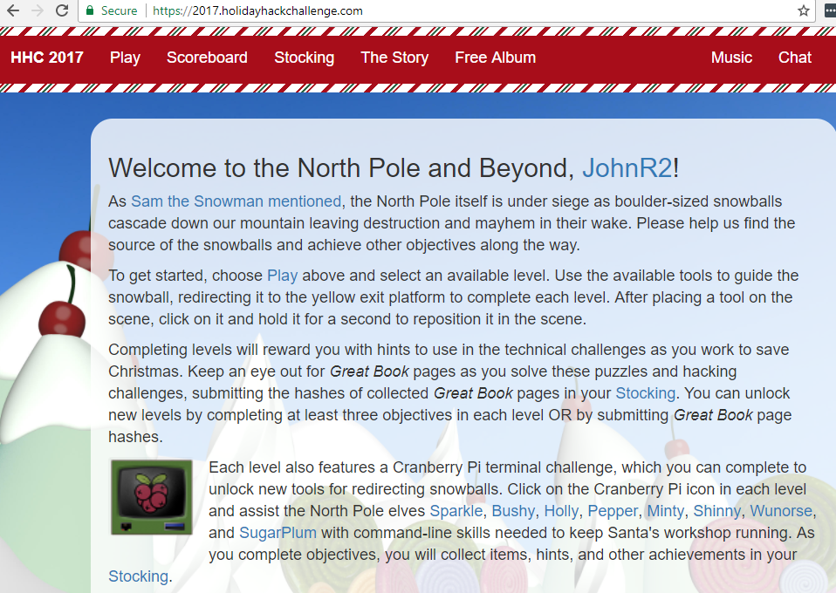

The links at the bottom, Sparkle, Bushy, etc., take you to Elf Twitter sites that have clues about the Linux Terminal Challenges.

To access the challenges, select Play. You should see this. 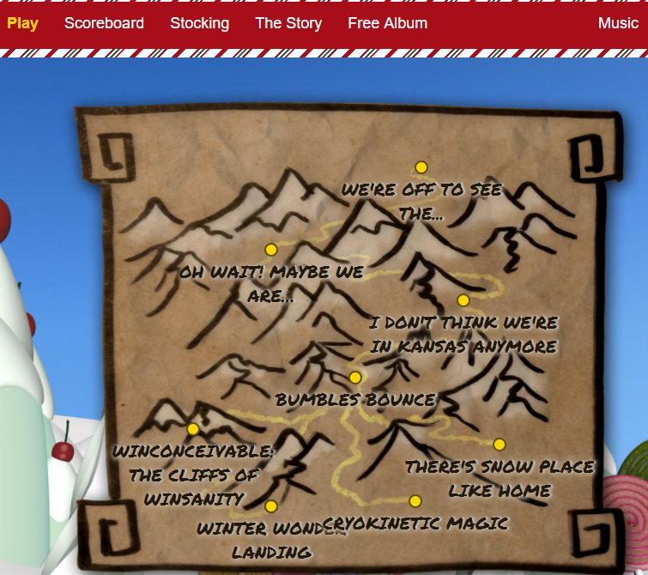

The first Linux terminal challenge we will do is Winter Wonder Landing at the bottom. You don’t need to play the snowball game. Just click on the terminal icon that is on top of the box.

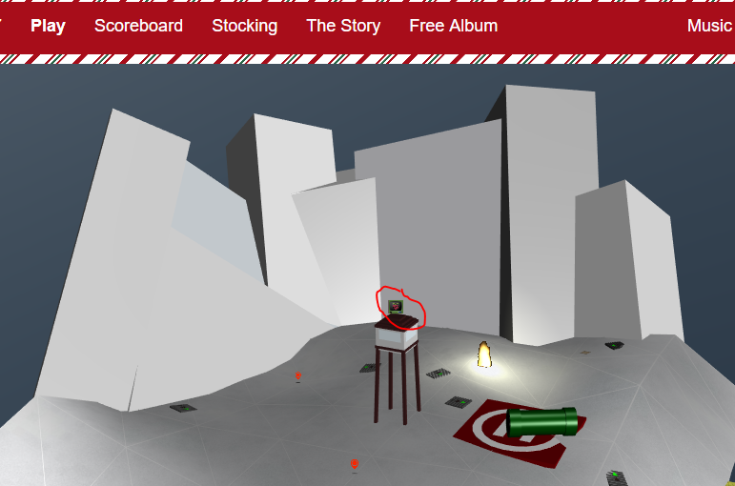

The terminal should appear.

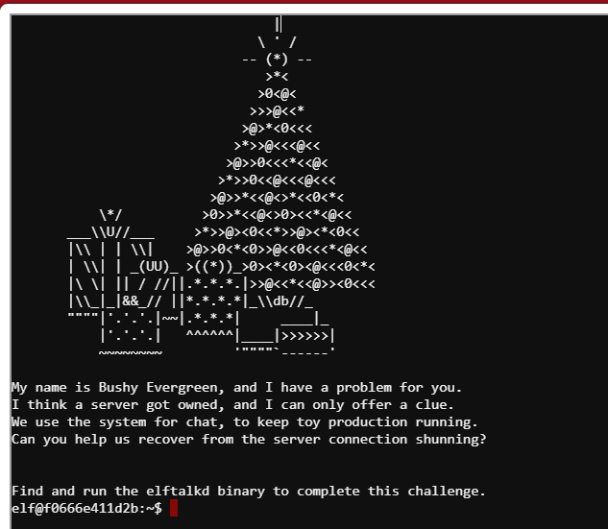

The problem here is that the “find” command is not easilly accessible. 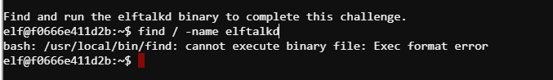

Bushy’s tweet is a clue.

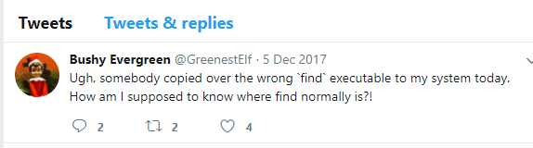

The key part is, “How am I supposed to know where find normally is?!” The linux terminal is based on Ubuntu. Kali is also based on Ubuntu. Hmmm. If you can answer Bushy’s question you can solve the challenge.

# Questions

1. The command you used to find elftalkd, and the command you used to start efltalkd.
2. When the terminal shows up in your stocking, you’ll see that it is called the Linux command hijacking terminal challenge.
   1. Look at the path that the terminal uses.
   2. Compare the paths to the bogus version of find, the real version of find, and the path from step a.
   3. Why is this challenge called Linux command hijacking, and how did it work?